Professor can register course when enter this page

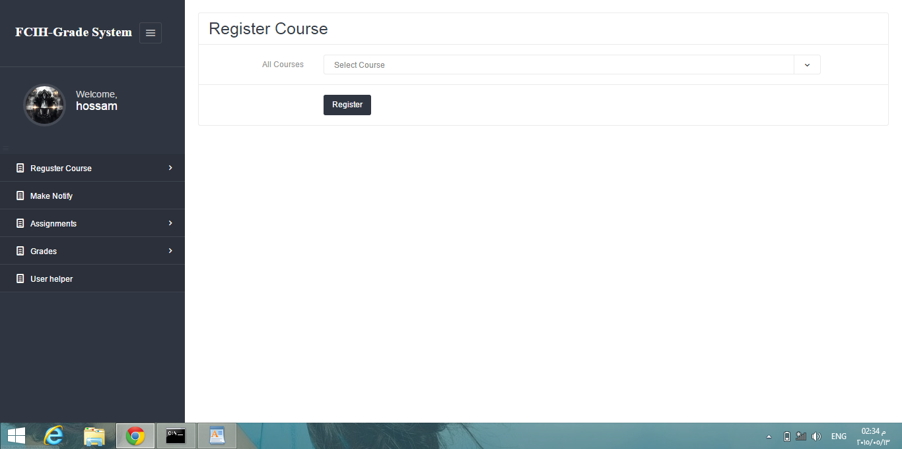

=============================================

Professor can add fields for this course when enter this page

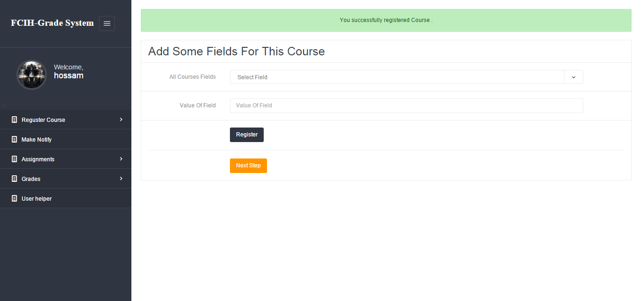

And can assign teachers to work with him in this course :

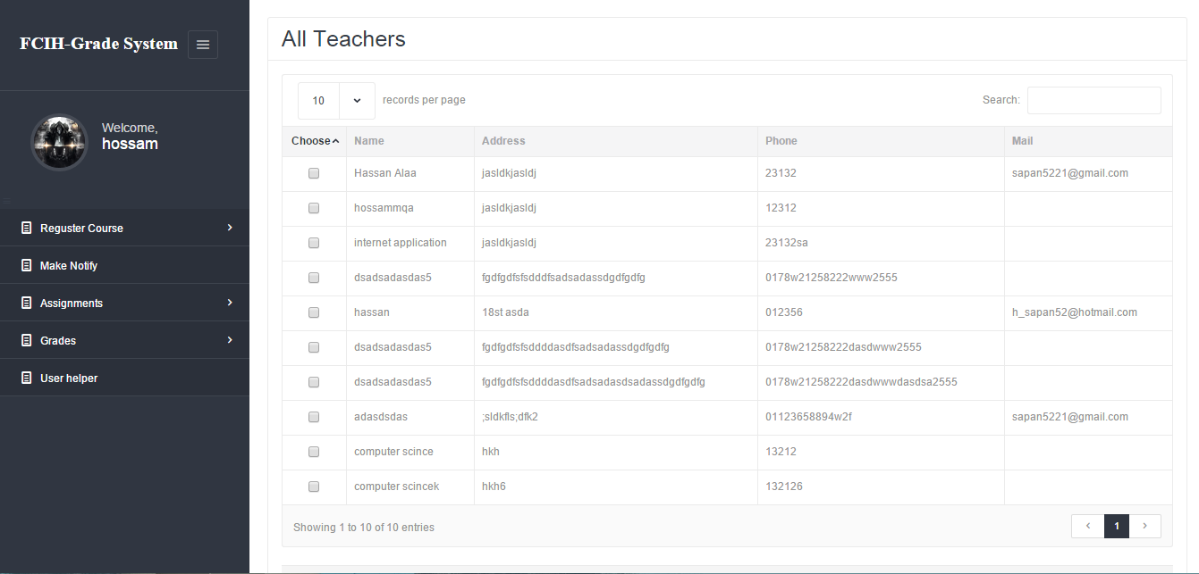

================================================

Administrator can define the deadline and close it to make allow the student can register courses or not

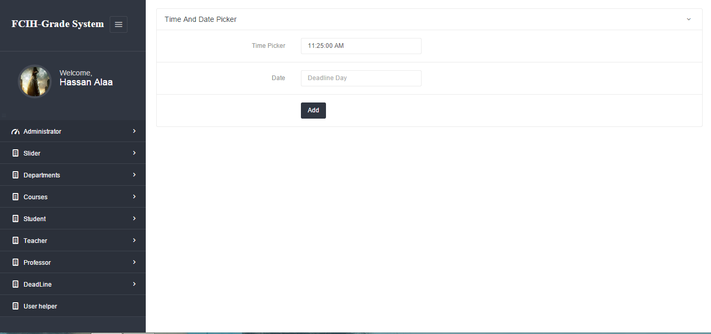

User rules for professor to know what he can do in this system

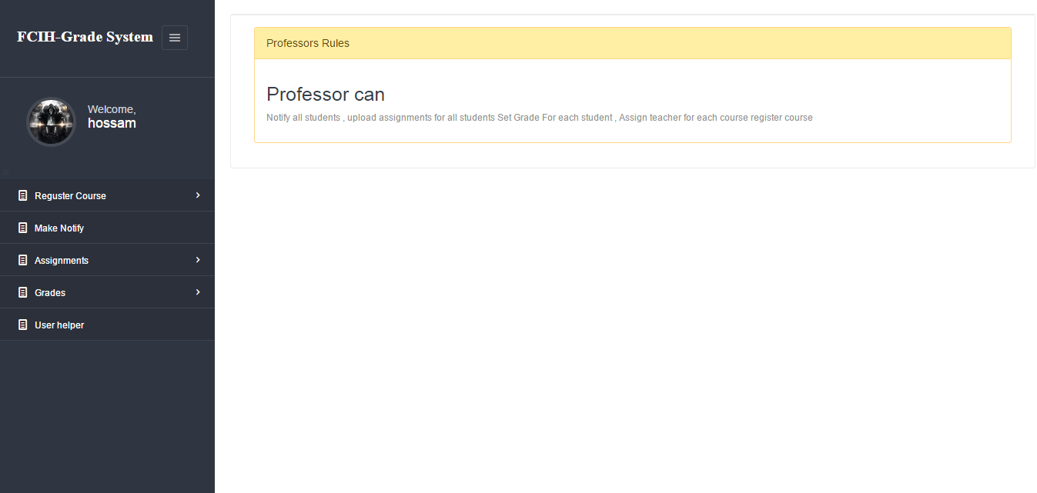

Administrator can add images to appear in system home page.



Professor can (make post ,upload assignment ) for each student and notify them

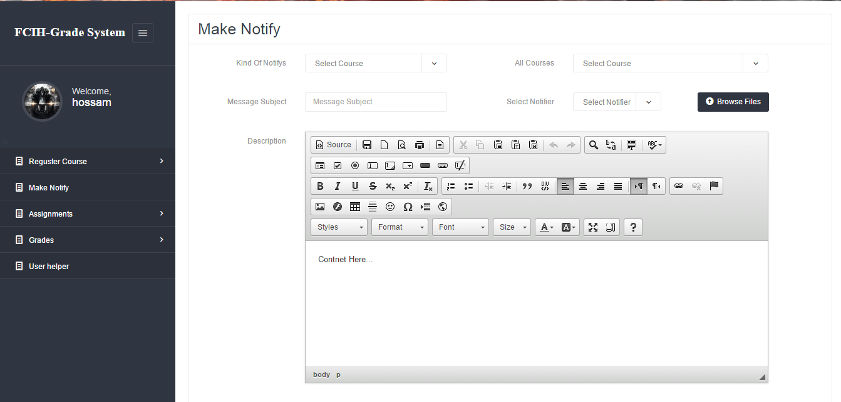

Set grade(final , midterm,project,other,assignment) for each student

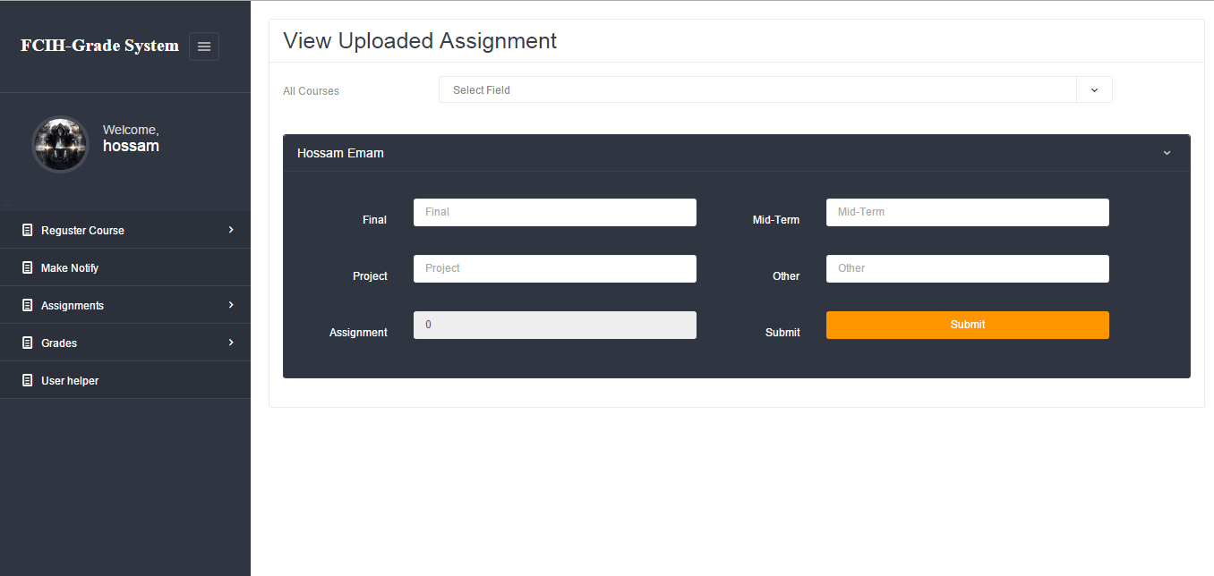

Professor can view all uploaded assignment and set grade for each assignment

